A close up of a sign

Description generated with very high confidence**Hawks COVID 19 Guidance:**

**Understanding the risks associated with playing modified netball**

Whilst comprehensive measures have been put in place to reduce the risk of transmission, there is an increased risk associated with taking part in netball.

Review the video about the health risks and mitigation steps England Netball have put in place here:

<https://www.youtube.com/watch?v=9qYJrHfXzZ0&feature=youtu.be>

**Your personal risk assessment**

If you have underlying health conditions and are considered clinically extremely vulnerable or moderately vulnerable, there is increased risk in taking part in netball activity. If you are 60+, male, lower-socio economic status or from a Black, Asian or minority ethnic background, you are more likely to get seriously ill from coronavirus.

Download the personal risk assessment [**here**](https://d2cx26qpfwuhvu.cloudfront.net/englandnetball/wp-content/uploads/2020/08/17154330/Ref-13.-Personal-risk-assessment-final.pdf).

**Do you want to play? Opt in**

Pressure will not be placed on players to participate or compete if they are uncomfortable with the risks associated with netball activity. Hawks will welcome players back whenever they are ready.

Players who want to return to netball with Hawks will have to review and agree to ‘opt in’

Download the ‘opt in’ statement [**here**](https://d2cx26qpfwuhvu.cloudfront.net/englandnetball/wp-content/uploads/2020/08/18124038/Ref-6.-Opt-In-guidance-updated.pdf).

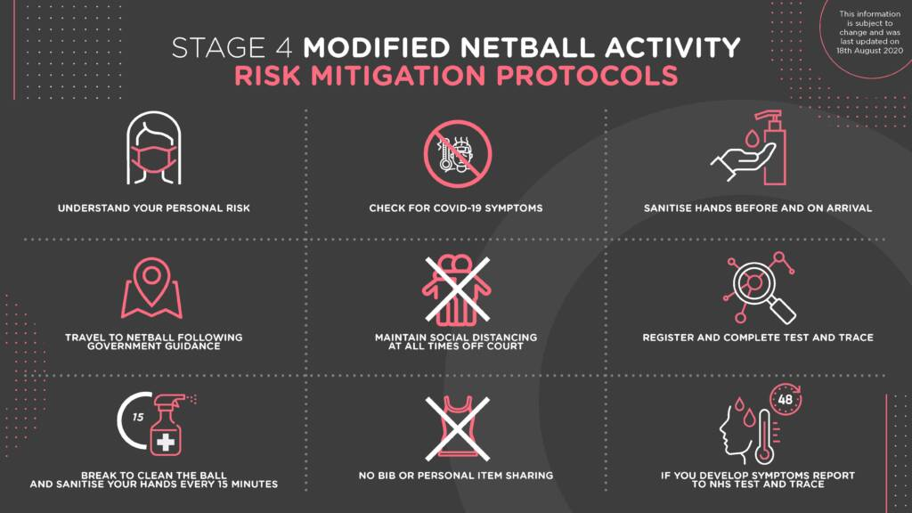We will ask players to sign this opt-in sheet (bring your own pen please) at their first session, and we will also create an online form that players can respond to via a message thread online in Pitchero to confirm their acceptance and opt in to netball with Hawks.