A close up of a sign

Description generated with very high confidence**Hawks COVID 19 Guidance:**

**New rules for modified netball**

**Firstly ensure you comply:**

**Sanitisation and Equipment**

All players are required to sanitise their hands every 15 minutes during activity.

All players should use their own netball wherever possible. Where your club provides balls, only sanitised balls should be used and it is required that they are sanitised every 15 minutes during activity.

Bibs should not be shared. Your netball organisation will let you know what arrangements are being made where not enough sets are not available. Water bottles and whistles should also not be shared.

**Social Distancing**

Wherever possible, social distancing will be incorporated into warm up activities and small sided games.

The following must not take place during any training sessions or netball matches:

* **Nail checks should take place from 2m**
* **There should be no pre-match huddle – players should remain socially distanced for any pre-match team talk**
* **No pre-match or pre quarter ‘hands in’**
* **No shouting or cheering**
* **No quarter or half time huddles**
* **No high fiving**
* **No post-match hug circles or handshakes**
* **Any post-match paperwork should be shared digitally (this could be e mail or photograph)**
* **No post-match team teas**
* **Team selfies must be socially distanced**

**New rules:**

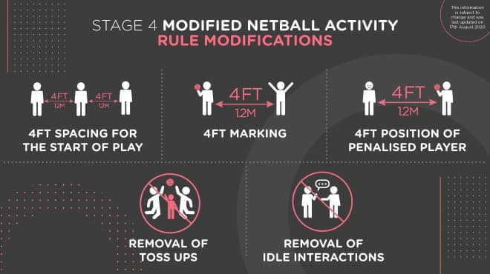

1. **4ft spacing for the start of play – GS and GK to start inside their goal circles, GA, GD, WA and WD on the transverse line and the centres in the centre third. Must be 4ft away from all players**

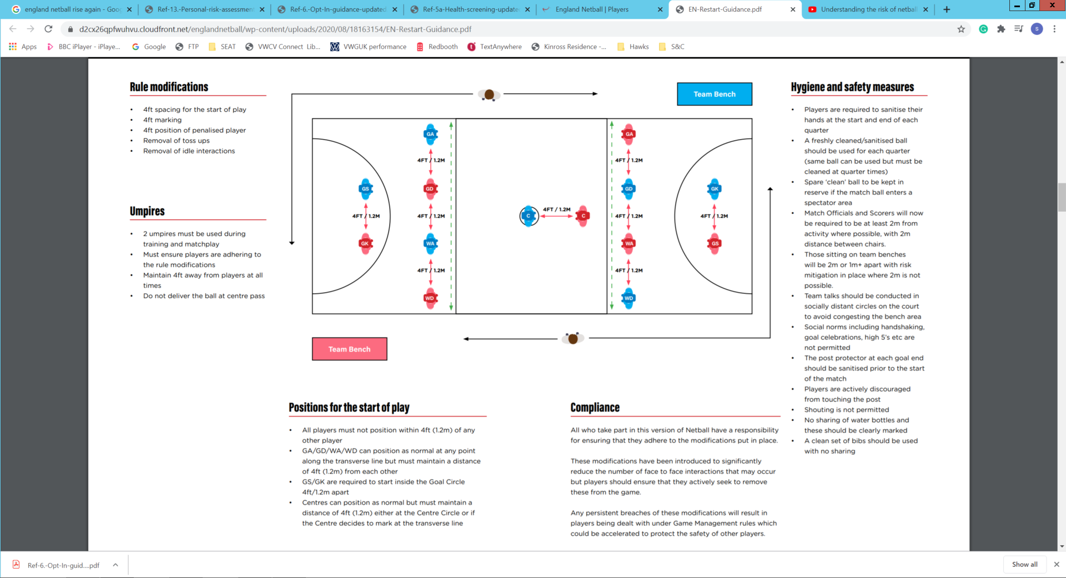

1. **4ft marking – the defending distance has been increased from 3ft to 4ft. Particular attention must be paid in the goal circle when defending or waiting for a rebound under the goal post. This will be blown as distance.**
2. **4ft position of penalised player – penalised players for major infringements are required to position beside the player they infringed but from a distance of 4ft away. This will be managed by umpires when an infringement occurs.**
3. **Removal of Toss Ups – No toss ups are permitted, the team who had the ball directly before the action that caused the toss up to be awarded will retain possession. The umpire will briefly hold time, instruct the ball to be returned to the relevant team and play will be restarted on the umpire’s whistle.**
4. **Removal of idle interactions – Players not engaged in play or who are stood still are required to be positioned 4ft away from another player. This frequently happens on the circle edge, on the transverse line, whilst walking back to centre pass and returning to the team bench at the end of a quarter. Managed by umpires and supported by players and coaches.**

**A video on this guidance can be viewed here:**

**https://youtu.be/PWehcDeTh_A**

Despite the changes, the modified games still looks and feels very much like the version we know and love. Contesting for the ball is very much permitted providing players are involved in the phase of play. Over the coming weeks we’ll be providing hot topic videos and hints and tips on playing, coaching and officiating the modified game.

All match play and competition will be played to these rules until social distancing is relaxed.

You will be reminded of rule modifications at start of session briefings. Circle players must take particular care of adhering to the modifications in the circle and will be continually prompted to do so.